|  |
| --- |
| Circle Language Spec: Parameters |

## Return Values in a Diagram

As discussed in the article *Return Values*, the new computer language does not limit the amount of output objects. Any object readable from the outside, may be an output object.

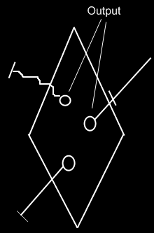

The correct usage of the term output will be discussed only later, in the *Advanced Command Topics*.